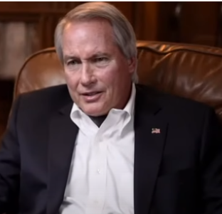
Lyn Wood, Attorney, Patriot – one of the best explanations, exposes, solutions I’ve ever heard about America’s present political mess. He is telling the Truth, is very grounded, committed and wants to protect spiritual basis of issues dealing with the future.
Very concerned with the mental perspective of Justice.
Compares Trump to Lincoln. Sets the record straight. Indicates that he has seen the evidence. Explains how we have been infiltrated by govt officials and the media working for other countries who want to take America down.
https://www.youtube.com/watch?v=OHtdA3Wj6vc

Is very concerned about the mental state of America and how we came to be so manipulated. Gives credit to communist China for being so blatant about their intentions to then actually taking over using electronics not guns. Is telling the TRUTH and provides solutions? Wants TRUTH to be the basis of our decisions. Would make a great leader – sees all sides. Explains what is happening, why it is happening and knows that is Truth was our guide then many high ranking govt officials are guilty of treason.
Ego involved only in terms of justice prevailing.
Wood says: “Truth decides what is good, what is bad.”
“When the media takes and event and ignores it you had better look out.”
“When the media takes something and censors it – go find it because that’s the truth being censored.”
“The lies are being broadcast, so America’s got to wake up.”
States he has seen the evidence and claims he could win in Court if the Truth would be allowed to be heard. Vulnerable point – doesn’t think the Truth will be heard or seen. Committed to keep his word. Claims Trump will be reinstated.
Opinion: I think this will be drug out over several months until the Truth comes out.
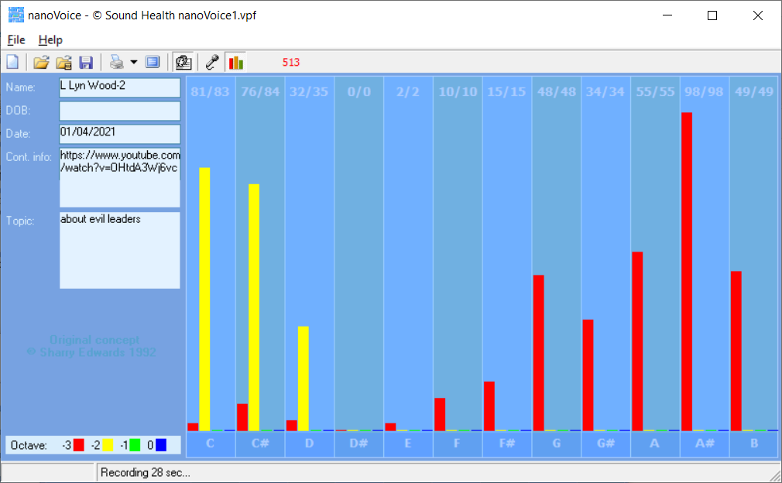
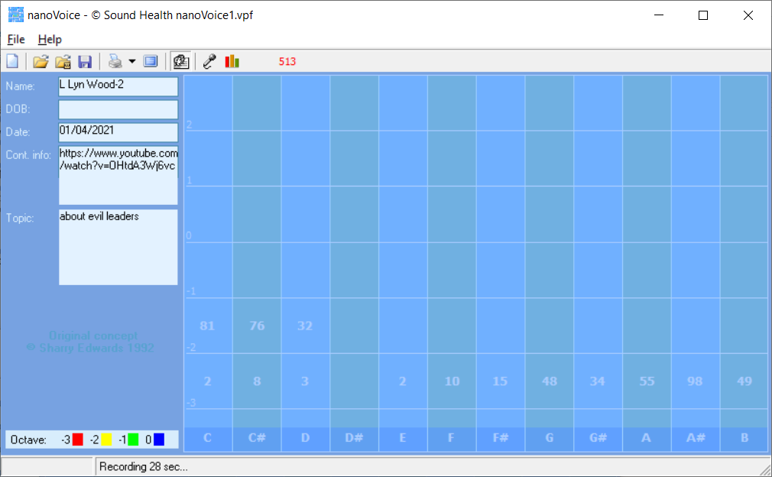

Computer Report
L Lyn Wood-2

Recording Date: 01/04/2021

Subject/Topic: about evil leaders

Missing Notes

You have no hits for the note(s) of: D#. Either you did not take enough samples (100-500 is usually best) or your subject matter did not include thoughts or topics that would involve this/these note(s). See the Note Correlate Chart that appears on the Cover Page for more explanation.

Points of Importance, Attention and Consequence

You think that feeding the mind is just as important as feeding the body. You are aware of how painful thoughtless words can be. Others see you as having leadership potential but they may resent you for the same reason. You have the ability to allow others to use your strength and support for their own needs.

Your highest note is associated with your internal perspective of service to self vs. humanitarian needs. The spirit of your inner core resides with your ability to take quiet time for yourself. Your highest note is associated with the expression of self power. The issues of circulation and stamina reside with this note. Your highest note is associated with the expression of justice, fairness and Truth. Joint, tendon and connective tissue issues, along with smooth muscle contractions, reside with this note.

The right words at the right time can sometimes elude you because of all of the internal dialogue. Thinking about an action is not the same as doing it, so go ahead and send that little gift, card or note. Ideas come to you in very odd moments when you are distracted by a required task.

Points of Communication, Complications and Complaints

You actively seek to bring spirit into your interactions with others. You have a strong sense of justice, fairness and Truth. You work well with others and are often put in a leadership position.

You wish someone could understand you without demanding a lot of conversation. You know how to get things done but don't always have the time to deal with the details. You can easily be distracted from carrying out your plans by a more exciting prospect.

