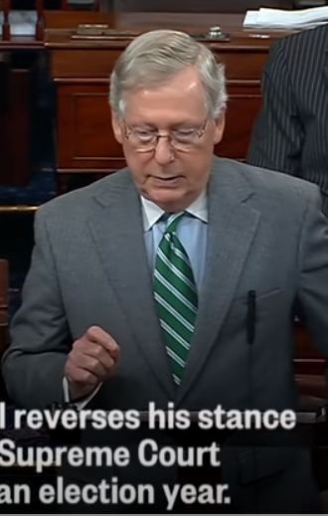
It was a surprise to me to see that Mich McConnel’s vocal print most closely matches that of Donald Trump over the same matter.
https://www.youtube.com/watch?v=_p5X4aH2h9M
McConnell is seeing this event from a whole brained perspective. He has a mental/emotional internal split dialog about the event.
He lacks foundation. The theme of his vocal print is primarily about control of information for a purpose. This lack of foundation comes from someone McConnell feels he must yield to. Fantasy for future outcomes is obvious in this vocal chart.

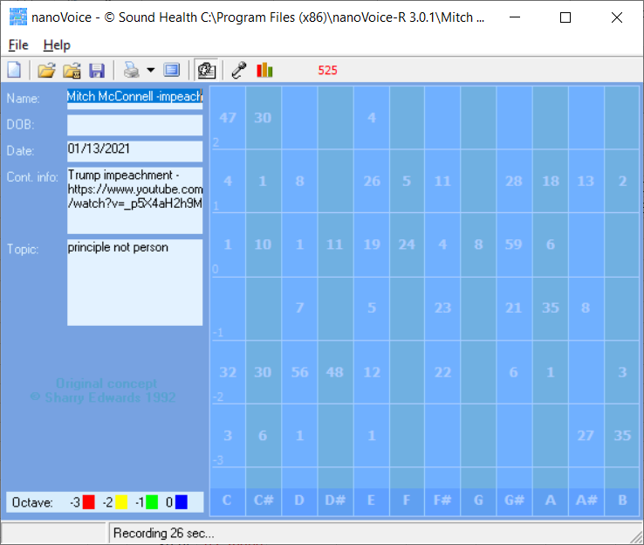
Mitch McConnell -impeach

Recording Date: 01/13/2021
McConnell is attempting to stay in a neutral position.
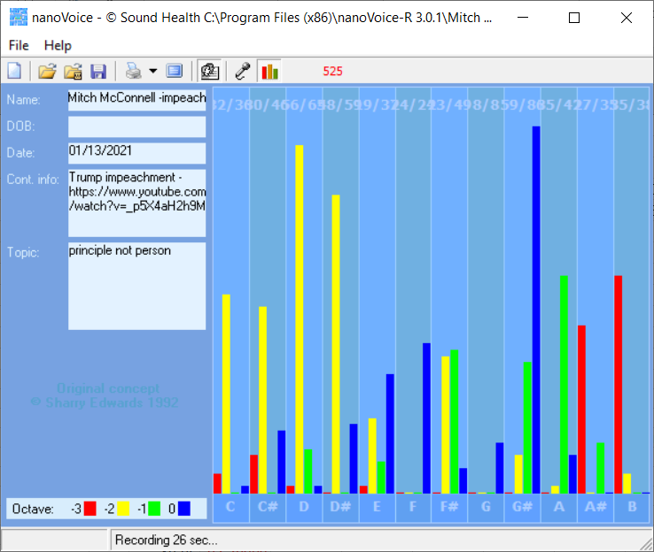 Subject/Topic: principle not person

Points of Importance, Attention and Consequence

You can be fussy about your physical space. It needs to satisfy you and no one else. Sometimes you spend a lot of energy trying to get even the smallest detail right the first time. You challenge the opinions of others with good reason. You have a high degree of intuition when it comes to listening to what people are not saying.

Your highest note is associated with the expression of physically prioritizing. Personal control over what happens in your physical environment resides with this note. Your highest note is associated with the expression of Self Approval and Self Worth. Issues of digestion, enzyme and energy production reside with this note. Your highest note is associated with seekers of internal Truth. The balance between self expression and self worth resides with this note.

Structure is not required for you to be comfortable. The right words at the right time can sometimes elude you because of all of the internal dialogue. Ideas come to you in very odd moments when you are distracted by a required task.

Points of Communication, Complications and Complaints

Your sense of achievement is closely tied to emotional gratification more so than fortune or fame.You have an internal sense of what is right using universal principles.

It is particularly bothersome when people use or borrow your property without permission. You work well with others and are often put in a leadership position. You have a strong sense of justice, fairness and Truth.

You can find what you need, so organization isn't really necessary. You know how to get things done but don't always have the time to deal with the details. Your connection to universal truths absorbs your time.

