Pelosi TEACHING congress and press a TACTIC To MANIPULATE the stupid public through media
Plandemic II - Pelosi bragging about manipulating the stupid public through media - Plandemic II –
29.:34 –
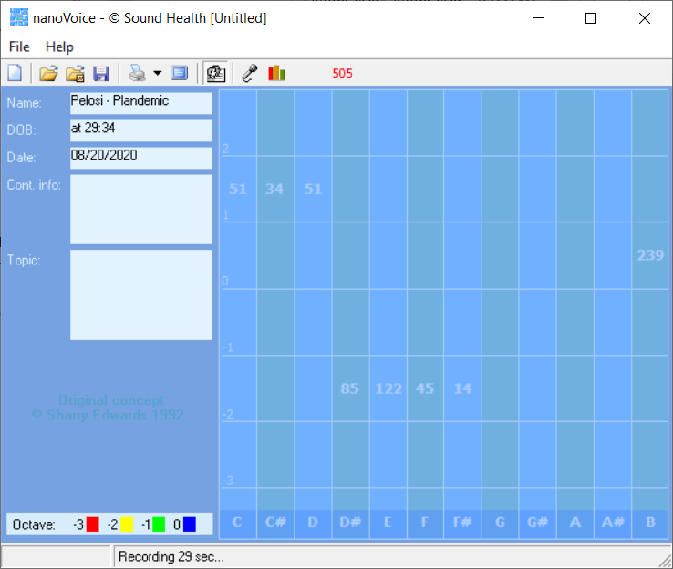
Pelosi: “You smear somebody with falsehoods and all the rest and then you merchandise it. And then you write it and they see it is reported in the press so they have that validation that the press reported the smear and then it is called a wrap up smear. Now I’m going to merchandise the press’s reporting on the smear that we made. And It is a tactic.”

[The BioAccoustic VoicePrint analysis of Pelosi by Sharry Edwards tells the hidden truths]
Fantasy EGO; thinks she is smarter than everyone else.
239 on naïve octave – same as AOC - has convinced herself that she is doing this for everyone’s good.
Congratulates herself that she will be seen as a savior. Withholding – only letting you know the small bit that she wants to have you do her bidding.
CONTROL with words is her goal. People need to see her for the control fanatic that she is.
No foundation at all – this is not her idea. This is similar to her voice when she made everyone stay and vote for Obama care.
Fancies herself as a great orator and manipulator with words. Justice is not her goal. Has no idea how to manage what she is creating.

