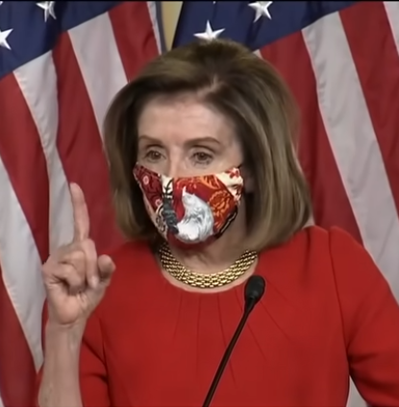
Pelosi attempted to defend her disgusting stand on release of the stimulus package for the people saying she doesn’t want to give Trump any comfort therefore denying the people any comfort. As with most of her Ilk, her print shows a need for control and manipulation. Not much of the truth is getting through now but Pelosi seems to be a major leader in this vile attempt to overthrow America.
Not too long-ago Pelosi went on record teaching her constituents how to lie and get the media to support the lies. This seems to come from her absolute need to control the lives that she thinks she has a right to dictate: Link - https://www.snopes.com/fact-check/nancy-pelosi-wrap-up-smear/.
Recently a letter attributed to Pelosi about her management of riotous behavior happening in Portland was published on the internet. Of course, she denied the letter. The letter is offered at the end of this document along with Pelosi’s actual signature for your comparison.
Her vocal print about this matter reveals:

A lack of foundation showing that she is not originating these ideas
A great need for control dealing with physical issues, and planning for the outcome of physical issues.
That her notice about how to manipulate and censor the press has been accomplished
Contains very little emotion or empathy

Lots of mental energy and planning has gone into this venture -she is carrying out the plan with little thought to the consequences.
Surprisingly does not contain a great deal of ego or justice perspectives
Is a bit naïve that her behavior is going to be overlooked and/or forgiven
Is fantasizing and her value to plan the fiasco that is happening. Whoever is behind attempted take over will be annihilate by those who conspired to support this attempted overthrow.
Believe their actions not their words. She thinks withholding the stimulus that she is supporting the people.
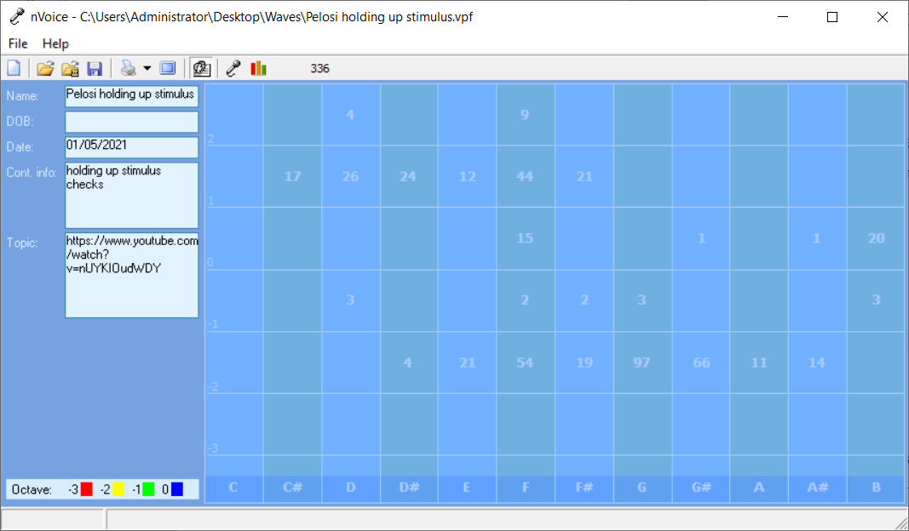

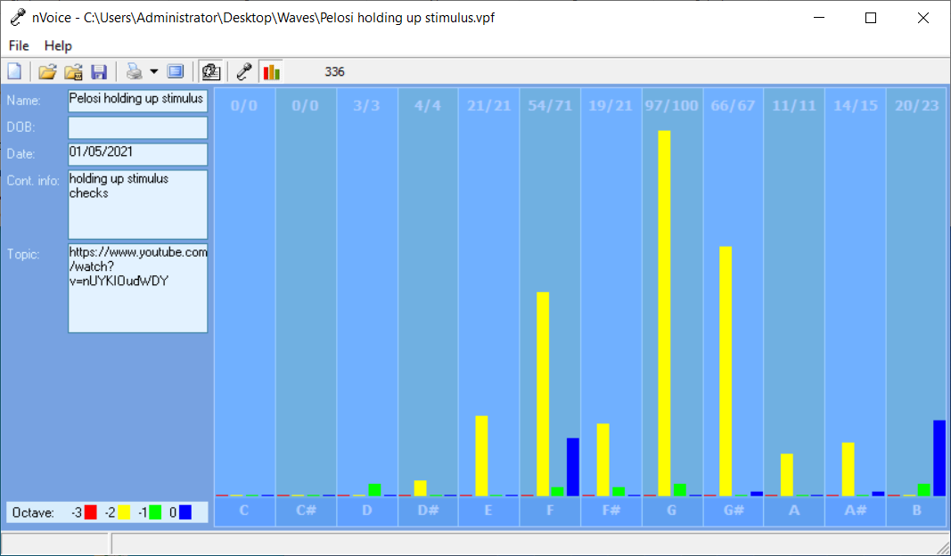
COMPUTER ANALSIS

Pelosi holding up stimulus

Recording Date: 01/05/2021

Subject/Topic: https://www.youtube.com/watch?v=nUYKIOudWDY

Missing Notes

You have no hits for the note(s) of: C, C#. Either you did not take enough samples (100-500 is usually best) or your subject matter did not include thoughts or topics that would involve this/these note(s). See the Note Correlate Chart that appears on the Cover Page for more explanation.

Points of Importance, Attention and Consequence

You know where your physical things are located even when others can't understand your system. You like control of your physical environment. Your stamina to get things accomplished is admirable. You want everything done but you do so much that some things don't get done on time. You can be fussy about your physical space. It needs to satisfy you and no one else. Sometimes you spend a lot of energy trying to get even the smallest detail right the first time. You plan well and want to see to it that your plans are carried out. It is easy for you to see the faults in others but don't always know how to get your point across politely. You expect others to take your suggestions seriously and gracefully. Nice things appeal to you and you are not averse to working hard to obtain them Your highest note is associated with the expression of what you consider to be your physical domain. Having dominion over your physical environment resides with this note. Your highest note is associated with the expression of physically prioritizing what you need and want to accomplishment. Personal control over what happens in your physical environment resides with this note. Your highest note is associated with the expression and integration of appropriate perception and action. The ability to assess a situation quickly resides with this note

You can sometimes do too much for others in the hopes of helping them change. You do for others before you do for yourself. It is a struggle sometimes to decide what you really think and what part belongs to someone else because you are so empathetic. Defining your own ideals and what you want from life is the first step to not following a wrong road. You can see what is the best for others but sometimes ignore what is the best for you. You tend to learn by example. You are often haunted by thoughts of what you should have done. You may be caught once in a situation but you aren't often caught twice without a proper answer. You are often distressed by verbal arguments and loud talking. People who use their position of authority to manipulate others disturb you to a point of action. You often think you should do more than you have time to accomplishment. Being able to prioritize what needs to be done emotionally is not always easy for you. You have the ability to just shut down when you are overwhelmed. Your metabolism shows be a weak point in your vocal print

Points of Communication, Complications and Complaints

Being able to appreciate your environment is important to you. Comfort in your environment needs to be balancing with pleasing colors and functionality. You like your working environment to be efficient with things readily available.

You have the ability to plan for yourself and others. You can easily show others how to put a plan together. You can get satisfaction out of being able to find and correct mistakes.

You have the ability to organize and prioritize in your head. It may not look that way to others but it is your mode of operation. You like to organize yourself so that everything is at hand and easy to utilize. It is particularly bothersome when people use or borrow your property without permission.

You can be talked out of your own opinions if solid evidence is presented because you are open to new ideas. You can sometimes feel criticism too quickly and too personally because you want to be more aware of your self issues. You can be very hard on yourself - taking blame or responsibility - that does not really reside with you. You sometimes fail to defend yourself because you don't want to criticize the opinions of others. In your desire to be of value to the growth of others you will learn that doing for others too quickly is not good for them.

You wish for the best which sometimes leads to statements of hope instead of statements of fact. You may need more than one chance to express yourself to get it right. Practice speaking your ideas before you enter into dialogue. Meditating about a situation or playing it over in your mind will clarify your stance and help you clearly represent your ideas. Being in stress will likely affect your breathing. You trust until you get hurt even though making people earn your trust is more logical.

You have a tendency to neglect your spiritual growth by maintaining too heavy a work load. You would like to have more time to spend on spiritual things. You have a hard time prioritizing what you want to do first.

Points of Cooperation, Learning, Opportunity and Growth

You have the ability to perceive what others may be thinking and can use it to your benefit. Your verbal skills make you a good trainer. You have the ability to play word games. You would make a good mediator.

You dislike being accused of something you did not do because it hurts your spirit. When you are satisfied with your decision, you no longer need to talk about it. You have the ability to influence others from a spiritual perspective.

Organizing your space in your own way is important to you. You delight in seeing the results of what you have physically accomplished. You enjoy the company of people who are comfortable with the natural environment. You have many physical sides that you present at your whim.

Spiritual laws and what's RIGHT is more important than Man's laws. Protecting people's feelings is very important to you. You ability to help others through emotional turmoil is admirable.

You have good intention about bringing your plans to fruition. You seem disorganized to the casual onlooker. You would like more options about your physical surroundings.

You don't always take time for the spiritual side of life. Balance between spiritual and physical aspects of your being is important. You have the ability to allow your spirit to carry you when the body is weak.

You want it done right the first time. You have the ability to see what won't work when others present you with a plan. You like verbal excitement via words and music.

Expressing your true emotions is a private matter for you unless justice is involved. You would just as soon that people keep their opinions about you to themselves. Being comfortable is more important to you than your image.

There are indications that issues with cellular oxygenation may need monitoring. Identifying which foods are most compatible with you is important to your digestive health. The process of digestion needs to be considered via enzyme evaluation.

You plan well but are sometimes short on the follow through because there just doesn't seem to be enough time to get it all done. The cooperation of others is essential to accomplish all that you conceive. You limit yourself with impatients when others get in the way of your plans.

Taking points and phrases from people who want the Truth to come out. Pelosi letter to Td Wheeler
freedomhttps://www.youtube.com/watch?v=nUYKIOudWDY

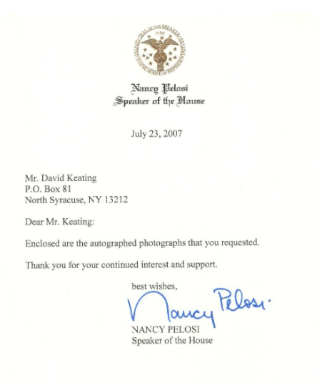

https://www.usatoday.com/story/opinion/2019/07/28/democrats-can-beat-trump-2020-with-2018-playbook-not-2016-column/1828384001/

https://operationdisclosure.blogspot.com/2021/01/more-proof-pelosi-is-traitor-anonymous.html#more

