Dan Crenshaw - https://www.youtube.com/watch?v=xKz0AAA_ukI

Called about Pelosi about holding up stimulus

I rise today to unequivocally condemn in the strongest possible terms the action of the speaker of the House, Nancy Pelosi – referring to her obstruction to the relief bill that we could have voted on.

Dan Crenshaw – Texas Representative and former Navy SEAL speakes before the US Senate stating that “I rise today to unequivocally condemn in the strongest possible terms the action of the speaker of the House, Nancy Pelosi – referring to her obstruction to the relief bill that we could have voted on.”
His vocal print reveals that he has a strong foundation and is speaking from a factual perspective. Getting supportive information to the people is his strongest commitment. He is also concerned about the how his information is going to be used in the future.
He is putting other first. He does not know how this is going to play out. By making these statements he is likely putting a target on his back. He would make a great strategist to get out of this political mess.

He is concerned where is words are going to fall.
The Truth should win. He is questioning who is censoring ius? Crenshaw is telling the Truth, stating the obvious – he is one of the good guys.
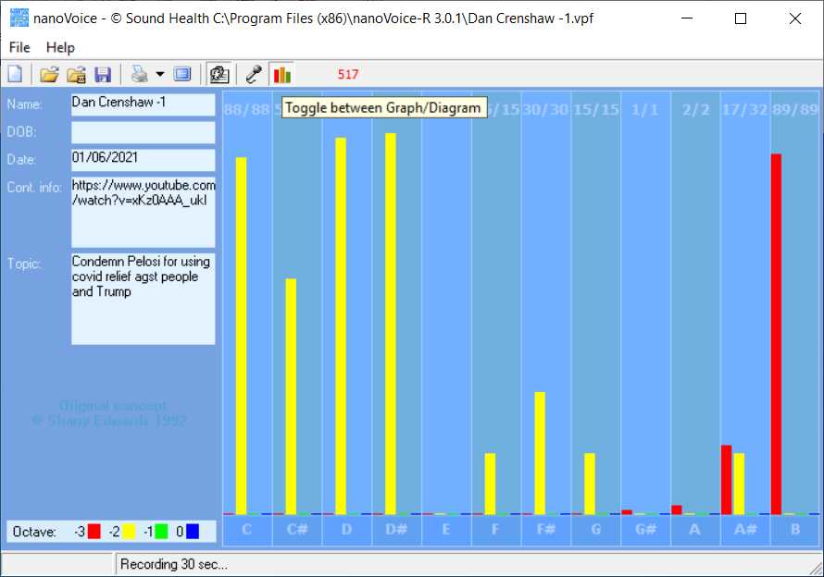
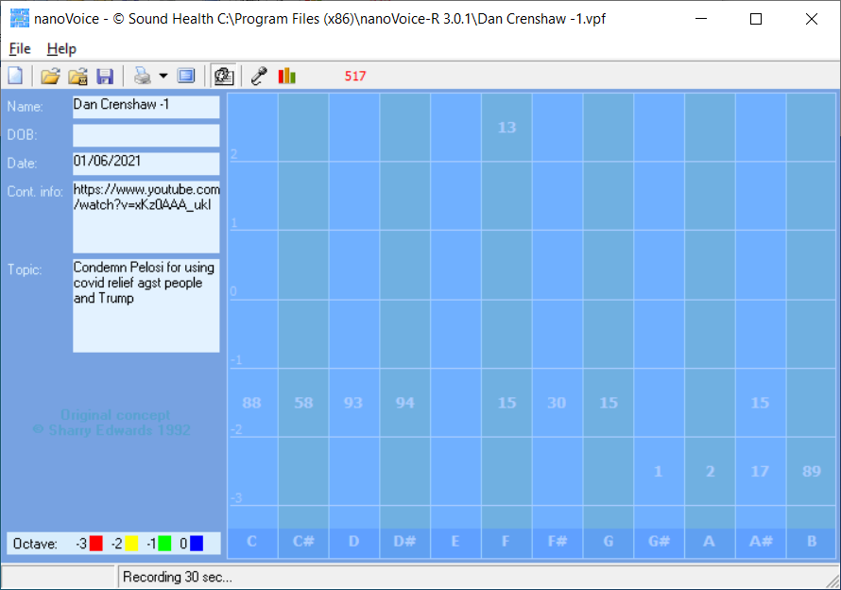

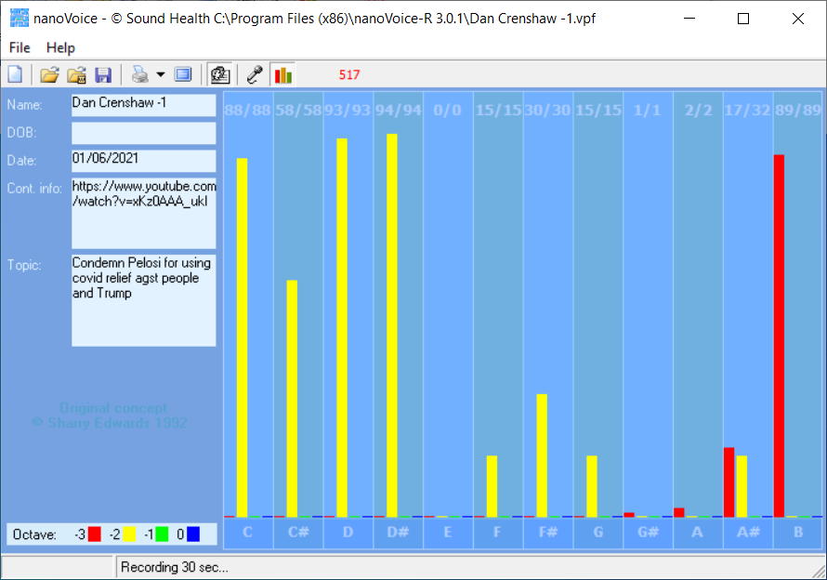

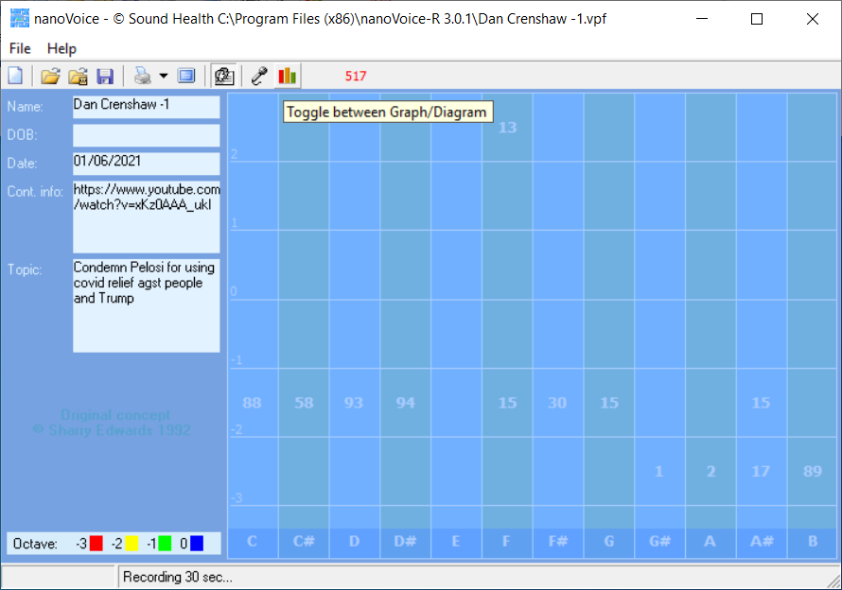

Dan Crenshaw -1

Recording Date: 01/06/2021

Subject/Topic: Condemn Pelosi for using covid relief agst people and Trump

Missing Notes

You have no hits for the note(s) of: E. Either you did not take enough samples (100-500 is usually best) or your subject matter did not include thoughts or topics that would involve this/these note(s). See the Note Correlate Chart that appears on the Cover Page for more explanation.

Points of Importance, Attention and Consequence

You have a high degree of intuition when it comes to listening to what people are not saying. You challenge the opinions of others with good reason. You have high ideals and expect the same of others.

Your highest note is associated with seekers of internal Truth. The balance between self expression and self worth resides with this note. Your highest note is associated with the expression of Self Approval and Self Worth. Issues of digestion, enzyme and energy production reside with this note. Your highest note is associated with service to humanity and human spirit. Your feelings and desire to help others resides with this note.

Having someone help you get started gets the job done faster. Being able to prioritize what needs to be done emotionally is not always easy for you. Your metabolism shows to be a weak point in your vocal print. Structure is not required for you to be comfortable.

Points of Communication, Complications and Complaints

You understand that trust should be earned but often trust without reservation. You tend to teach by your actions. You sometimes help others to the detriment of yourself. Your emotions run strong and can influence your health.

You know how you want things to look but sometimes don't have the energy to make it so. You would like to have more time to spend on spiritual things. You have a hard time prioritizing what you want to do first. You can find what you need, so organization isn't really necessary.

